Epoch 1/15

WARNING:tensorflow:Gradients do not exist for variables ['complex_model_with_rotat_e_1/entity_embedding/embeddings:0', 'complex_model_with_rotat_e_1/relation_embedding/embeddings:0'] when minimizing the loss. If you're using `model.compile()`, did you forget to provide a `loss` argument?

WARNING:tensorflow:Gradients do not exist for variables ['complex_model_with_rotat_e_1/entity_embedding/embeddings:0', 'complex_model_with_rotat_e_1/relation_embedding/embeddings:0'] when minimizing the loss. If you're using `model.compile()`, did you forget to provide a `loss` argument?

WARNING:tensorflow:Gradients do not exist for variables ['complex_model_with_rotat_e_1/entity_embedding/embeddings:0', 'complex_model_with_rotat_e_1/relation_embedding/embeddings:0'] when minimizing the loss. If you're using `model.compile()`, did you forget to provide a `loss` argument?

WARNING:tensorflow:Gradients do not exist for variables ['complex_model_with_rotat_e_1/entity_embedding/embeddings:0', 'complex_model_with_rotat_e_1/relation_embedding/embeddings:0'] when minimizing the loss. If you're using `model.compile()`, did you forget to provide a `loss` argument?

1682/1682 [==============================] - 2818s 2s/step - loss: 2.4795 - accuracy: 0.5018 - val_loss: 0.9382 - val_accuracy: 0.5074 - lr: 5.0000e-05

Epoch 2/15

1682/1682 [==============================] - 2806s 2s/step - loss: 0.7496 - accuracy: 0.5526 - val_loss: 0.7019 - val_accuracy: 0.5068 - lr: 5.0000e-05

Epoch 3/15

1682/1682 [==============================] - 2797s 2s/step - loss: 0.3933 - accuracy: 0.8451 - val_loss: 0.9199 - val_accuracy: 0.5089 - lr: 5.0000e-05

Epoch 4/15

1682/1682 [==============================] - 2795s 2s/step - loss: 0.0923 - accuracy: 0.9751 - val_loss: 1.3077 - val_accuracy: 0.5101 - lr: 5.0000e-05

Epoch 5/15

1682/1682 [==============================] - 2924s 2s/step - loss: 0.0247 - accuracy: 0.9982 - val_loss: 1.6585 - val_accuracy: 0.5099 - lr: 2.5000e-05

Evaluation Metrics:

Precision: 0.5046

Recall: 0.4224

F1 Score: 0.4598

ROC AUC: 0.5089

PR AUC: 0.5260

MCC: 0.0078

y_pred = (test_scores > 0.6).astype(int)

y_true = y_test.astype(int)

# Calculate evaluation metrics

precision = precision_score(y_true, y_pred)

recall = recall_score(y_true, y_pred)

f1 = f1_score(y_true, y_pred)

roc_auc = roc_auc_score(y_true, test_scores)

pr_auc = average_precision_score(y_true, test_scores)

mcc = matthews_corrcoef(y_true, y_pred)

# Confusion Matrix

conf_matrix = confusion_matrix(y_true, y_pred)

# Display evaluation metrics

print("\nEvaluation Metrics:")

print(f'Precision: {precision:.4f}')

print(f'Recall: {recall:.4f}')

print(f'F1 Score: {f1:.4f}')

print(f'ROC AUC: {roc_auc:.4f}')

print(f'PR AUC: {pr_auc:.4f}')

print(f'MCC: {mcc:.4f}')

Evaluation Metrics:

Precision: 0.9990

Recall: 0.0223

F1 Score: 0.0436

ROC AUC: 0.5089

PR AUC: 0.5260

MCC: 0.1060

y_pred = (test_scores > 0.7).astype(int)

y_true = y_test.astype(int)

# Calculate evaluation metrics

precision = precision_score(y_true, y_pred)

recall = recall_score(y_true, y_pred)

f1 = f1_score(y_true, y_pred)

roc_auc = roc_auc_score(y_true, test_scores)

pr_auc = average_precision_score(y_true, test_scores)

mcc = matthews_corrcoef(y_true, y_pred)

# Confusion Matrix

conf_matrix = confusion_matrix(y_true, y_pred)

# Display evaluation metrics

print("\nEvaluation Metrics:")

print(f'Precision: {precision:.4f}')

print(f'Recall: {recall:.4f}')

print(f'F1 Score: {f1:.4f}')

print(f'ROC AUC: {roc_auc:.4f}')

print(f'PR AUC: {pr_auc:.4f}')

print(f'MCC: {mcc:.4f}')

Evaluation Metrics:

Precision: 1.0000

Recall: 0.0222

F1 Score: 0.0435

ROC AUC: 0.5089

PR AUC: 0.5260

MCC: 0.1061

Εικόνα που περιέχει κείμενο, στιγμιότυπο οθόνης, διάγραμμα, ορθογώνιο παραλληλόγραμμο

Περιγραφή που δημιουργήθηκε αυτόματα

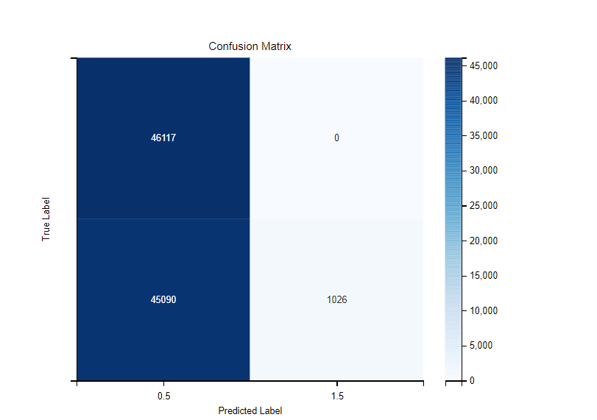

Εικόνα που περιέχει κείμενο, γραμμή, διάγραμμα, γράφημα

Περιγραφή που δημιουργήθηκε αυτόματα

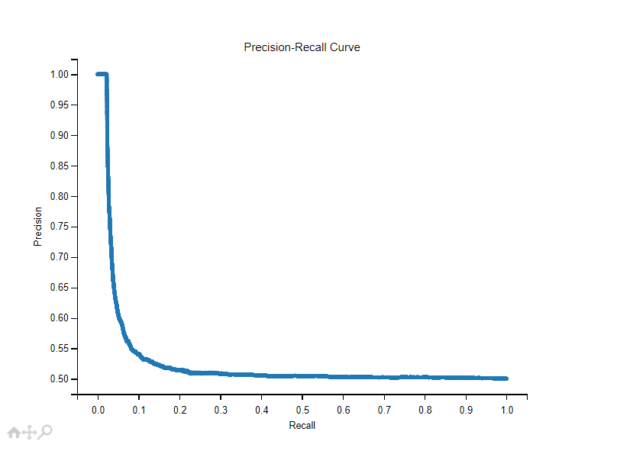

Εικόνα που περιέχει κείμενο, διάγραμμα, γραμμή, γράφημα

Περιγραφή που δημιουργήθηκε αυτόματα

Εικόνα που περιέχει κείμενο, στιγμιότυπο οθόνης, ορθογώνιο παραλληλόγραμμο, διάγραμμα

Περιγραφή που δημιουργήθηκε αυτόματα